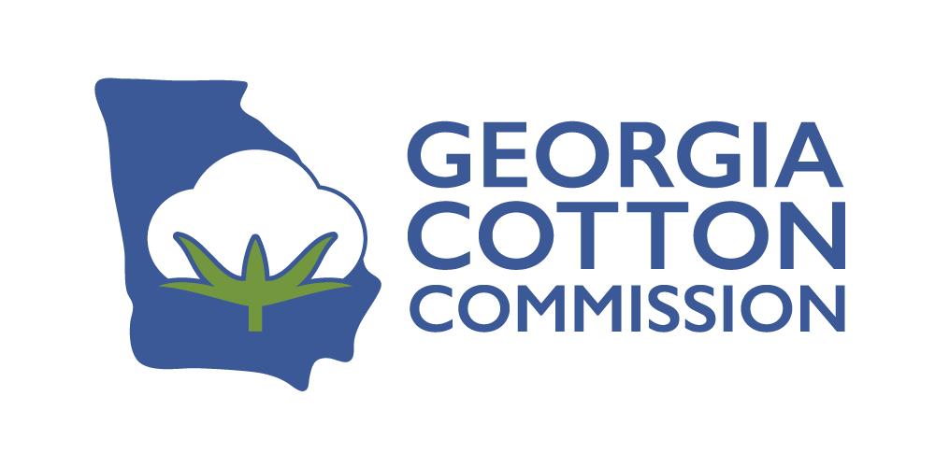
May 2026
FOR IMMEDIATE RELEASE
Georgia Cotton Commission Mid-Year Meeting July 29, 2026
The Georgia Cotton Commission is pleased to announce the guest speakers at the Commission’s 2026 Mid-Year Meeting scheduled for Wednesday, July 29, 2026, at the Nesmith-Lane Conference Center in Statesboro. The Mid-Year Meeting is held in conjunction with the UGA Cotton Pre-Harvest Workshop conducted by members of the UGA Research & Extension Cotton Team. The UGA Cotton Pre-Harvest Workshop will feature a program where attendees will receive updates revolving around the 2026 crop, with specific focus on agronomic and pest management considerations, as well as timely regulatory information that will help producers make decisions for 2026 and beyond.
The program speakers are Rusty Rumley, Senior Staff Attorney at the National Agricultural Law Center and Bev Sylvester, Chief Marketing Officer at Cotton Incorporated.
- Rusty Rumley is a Senior Staff Attorney with the National Agricultural Law Center and was born and raised on a family farm in Cogar, Oklahoma. After law school, Rumley earned is LL.M in Agricultural Law at the University of Arkansas. He is licensed to practice law in the states of Oklahoma and Michigan. His primary areas of interest are in estate planning, taxation, business organizations, landowner liability, industrial hemp, leasing, and agritourism.
- Bev Sylvester is the Chief Marketing Officer at Cotton Incorporated where she leads the organization’s marketing strategy across the textile and apparel value chain and consumer marketplace. In this role, she oversees trade and consumer marketing initiatives designed to increase the use of cotton in products and reinforce global demand for cotton. Sylvester brings more than 20 years of senior-level fiber marketing and brand leadership experience and has spent her career working closely with mills, manufacturers, brands, and retailers to translate fiber performance, sustainability, and traceability into market-relevant value propositions.

During the lunch program, the 2025 Georgia Quality Cotton Awards will be presented. There is no charge to attend. Pre-registration is requested to help with meal plans. Register online at www.georgiacottoncommission.org.
Thank you to our sponsors:
Stoneville/BASF – Deltapine/Bayer Crop Science – Tama USA – John Deere Farm Credit Associations of Georgia – Phytogen/Corteva Agriscience
Ag Insurance Advisors – Ag Technologies – American National – Americot, Inc.-NexGen Atlantic & Southern Equipment – Cotton Solutions Cooperative – Chandler Equipment – CNI ECOM Trading – Georgia Farm Bureau – Koch Agronomic Services – Langston Companies
Nutrien Ag Solutions – Olam Cotton/Liberty Cotton Cooperative ProCot Cooperative/Allenberg Cotton Company – R.M. King – S&K Packaging – Sentinel Ag
Silveus Southeast – Smith Farm Supply – Southeast AgNet – Staplcotn – Syngenta – Synovus Tidal Grow Agriscience – Tidewater Equipment/CASE-IH – Timac Agro USA Triangle Chemical Company – Triangle Insurance – Valent USA – Valley Irrigation
###

